

Deck
Financial Model
Patient experience deck

Company overview
- Branch Care’s Vision: To activate every zip-code in the world with accessible and high-quality fertility care.
- Branch Care Mission: To increase the reach of fertility care by expanding the reach of fertility specialists.
  - They refer to the OBGYNs, NPs, etc who use Branch to do some of the typical REI workflows as “Fertilty Extenders” – referred to in the financial model as “FEs”
- Branch Care’s technology supercharges the productivity and reach of REIs, OBGYNs, and APPs to create equitable, safe, and expansive access to fertility care.
  - Branch Care unleash the power of fertility data through predictive intelligence so that any provider (e.g., nurse, primary care provider, OBGYN, eventually sonographer, Phlebotomist) can safely administer and participate in the fertility care journey (thereby increasing the supply and reach of physicians)
  - Branch Care equips physician extension by providing fertility care under the virtual oversight of an REI through easy access to fertility data and automated care coordination
- It is a collaboration care management platform to unlock borderless care through a remote patient care coordination system utilized by their expanded network of fertility providers, all powered by organized and actionable fertility data to support improved outcomes and treatment selection across the board.
- There are 3 spokes of the business –
  - Branch Care’s Intelligence platform provides a deep understanding of what drives the best outcomes around treatment selection personalized to the patient / intended parent. Branch does this by aggregating a vetted database of patient variables including age, weight, AMH, and follicle count to optimize care. E.g., through our analytics platform we are predicting the likelihood that the patient will only need one or two cycles, as well as ensuring the best outcomes for thawing and using eggs down the line. We are also using data in the cycle itself to decide what medication dosing is most effective at what dosage to best optimize for the patient experience and outcomes.
  - Branch Care’s Patient coordination platform ensures timely engagement with patients and their physicians. With Branch, the patient can seek care locally from their physician all under the virtual oversight of the specialist provider, cutting out days - if not weeks - of costly and often disruptive travel to fertility specialists.
  - Branch’s Network ecosystem is powered by Branch Intelligence and Branch Patient remote care platform. We are able to create seamless integrations with technology to any referring physician office so that they can deliver localized fertility care under the treatment protocols of the supervising REI.

Business Stats / Traction
- 2M exclusive data points
- 4k patient interactions
- 60 contracted providers
- Have a partnership opportunity signed with Maiden Lane Medical and Spring Fertility ($4M total potential)
- 65% of referred patients complete diagnostics 25% of referred complete stim cycle 60% of stim cycles do repeat stim cycles

Workplan
- Review financial model and economics financial model financial model
- Customer references on both the REI referring clinic + the OB/PCP side
- Patient outcomes / live testimonials for the 130 you've served so far refer to patient experience deck
- Product roadmap see slides in appendix
- Any materials you can share on how you are getting them on board Refer to deck

Follow up questions
Sales
- What are the terms of the exclusivity partnerships with the two fertility clinics – how long are they for and what services are covered in the exclusivity?
- How are you meeting most of the OB/GYNs & fertility clinics in your pipeline right now?
- What % of current contracted providers are OB/GYNs vs. PCPs vs others?
  - Do you have an ROI analysis for OB/GYNs, PCPs, etc?
- Please share a weighted pipeline

Product
- What is the implementation process for the REIs and OBGYNs?
- How does Branch measure success on the patient side? Is it mostly about accessibility to an REI or are you tracking other metrics like # of cycles to pregnancy, time to complete cycle, etc? (+ do you have any data available for the women who have gone through Branch so far?)
- Are you able to share more about the demographics across the data set your model is built on? Curious because of SDoH / geographical differences that impact fertility.

Financials
- It would be great to talk through your business model together (especially whether the Branch Fee is just the take rate for coordinating services completed by the fertility extender, or if Branch is actually responsible for any of the services). We got the sense your biz model was mostly care coordination but see fertility nurses on the payroll so want to confirm.
  - If there is a care delivery component, do you ever plan to have in-person locations?
- For the SaaS product, we notice you assume max adoption of 7% in 2029 - it would be helpful to get the voiceover on the SaaS tooling and roadmap.
  - Do you plan to monetize the SaaS product through OB/GYNs, REIs, or both?
- You said the market sizing is a bit outdated - how are you thinking about your market size now?
  - Based on some back of the envelope math, there are about 435k ART cycles per year * $3150 in fees per cycle = ~$1.4B TAM. We know part of your thesis is that Branch will increase access to ART, so how do you think that will translate to TAM?

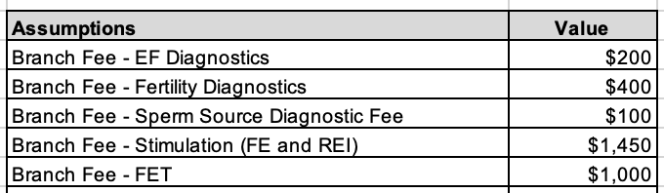

What do we need to believe
- Fundamentally my biggest question is really how willing are OBs and PCPs going to be to implement a new workflow, even if it is revenue generating? (ABG)
- Branch care can actually expand the total TAM beyond families who have already sought out ART services

Market Size
- 413k * 3150 = $1.3B
- 413k ART cycles in 2024 (source)

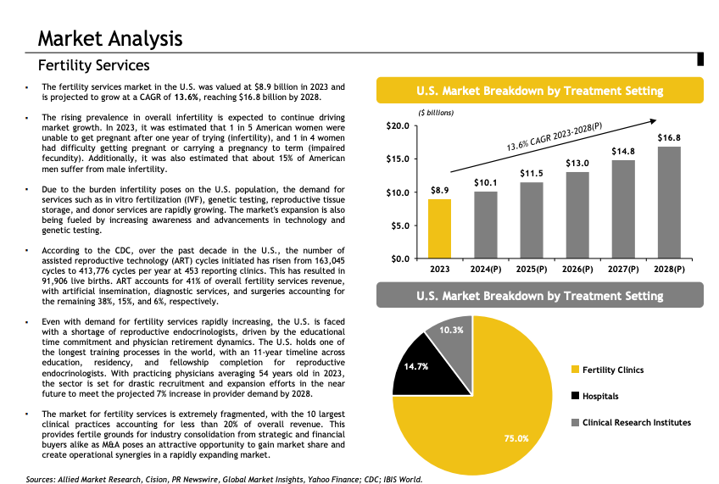

Use of Funds:
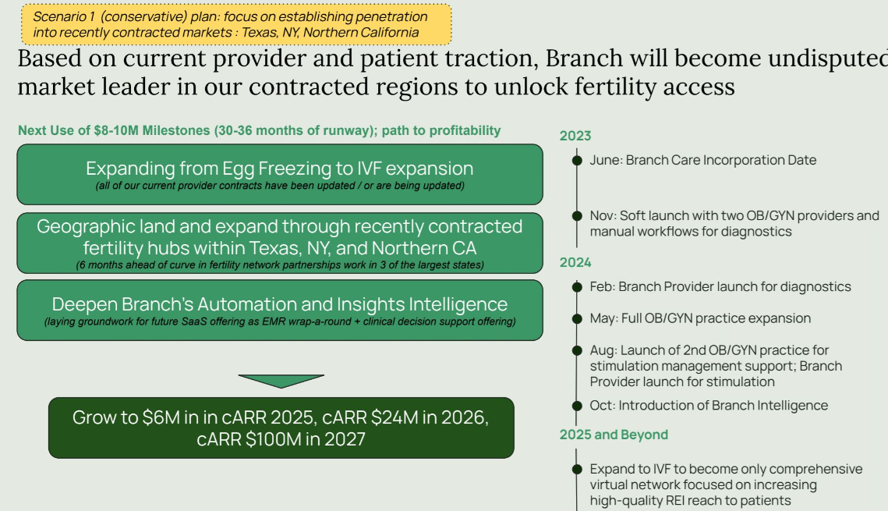

Product Overview:
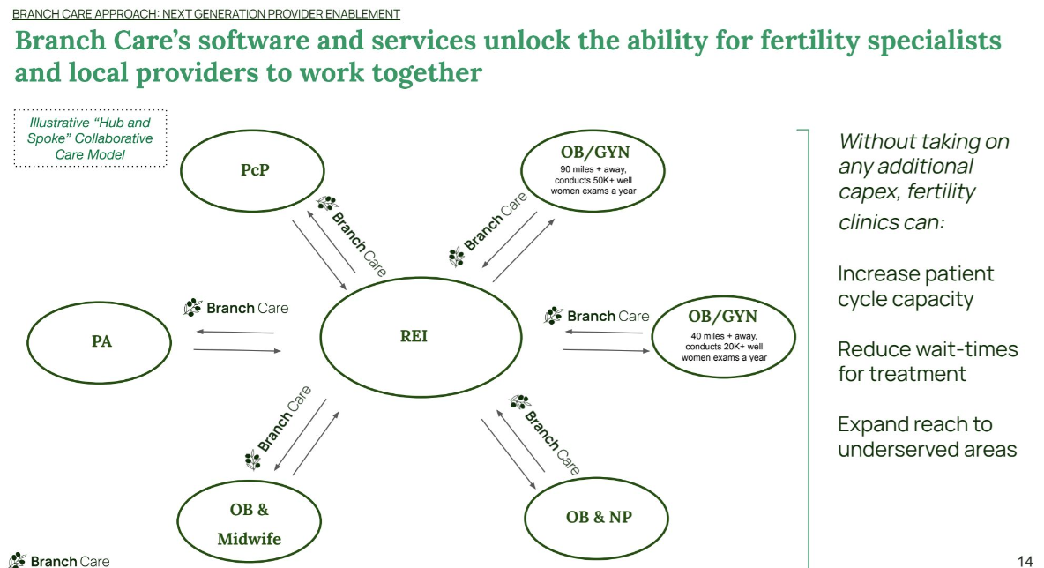
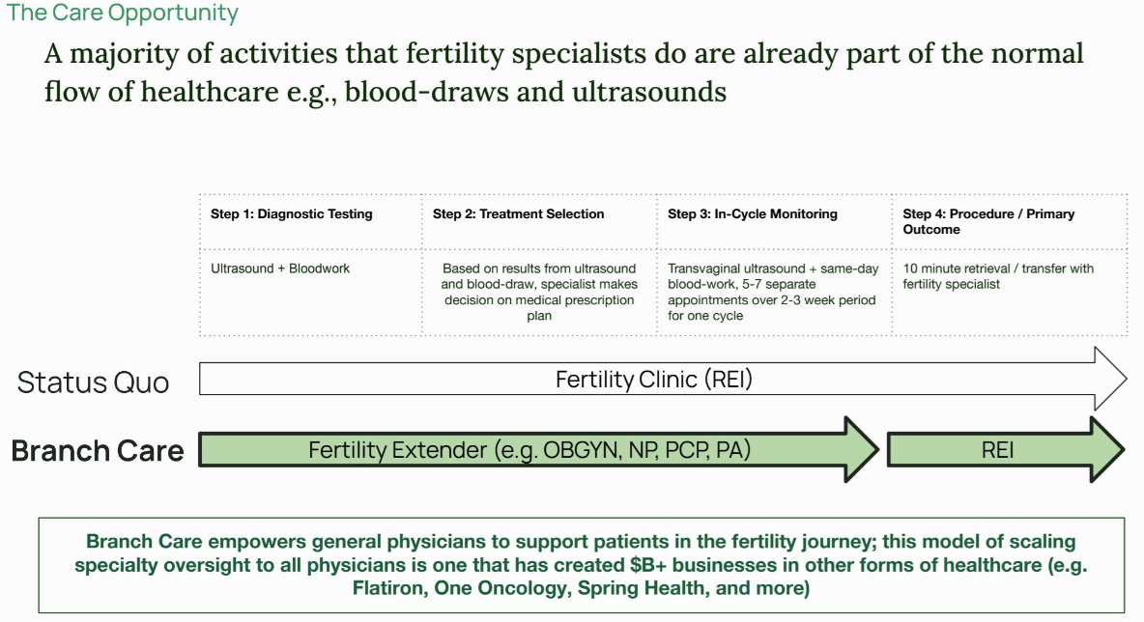

Business Model
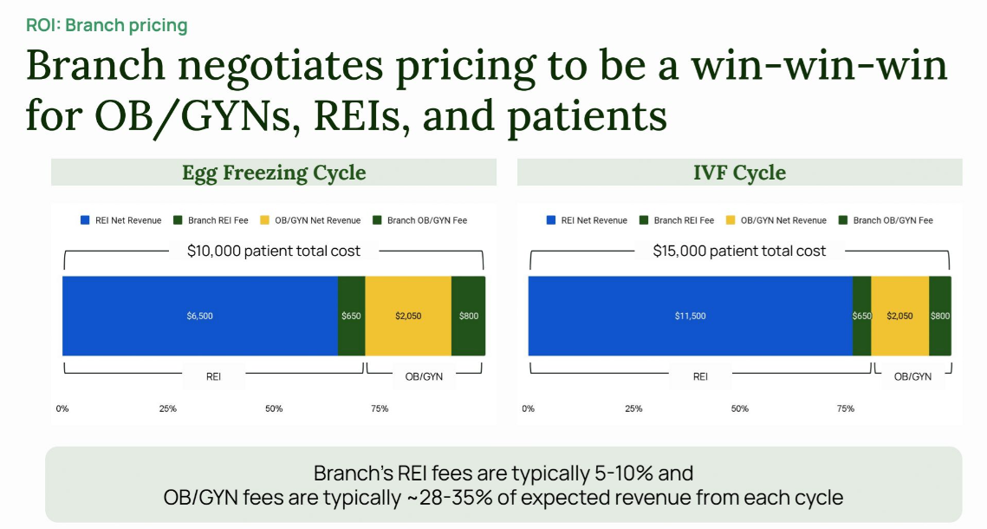

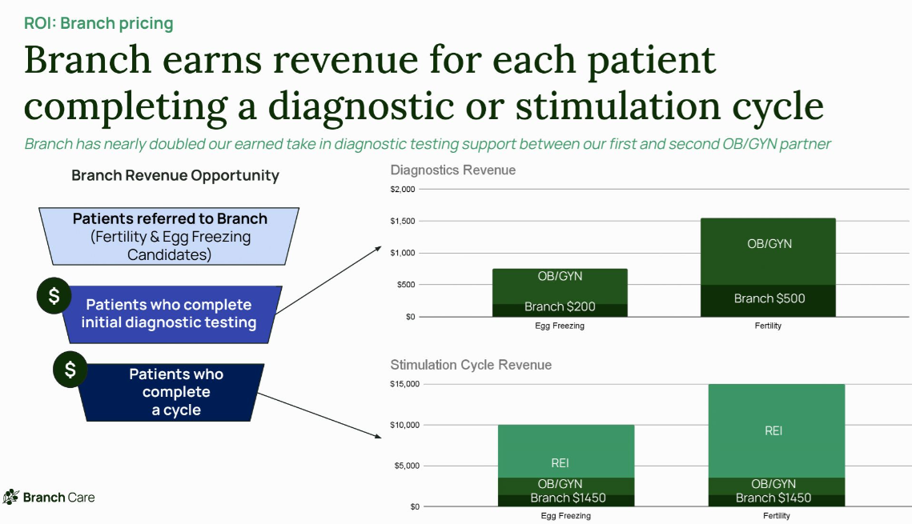

Roadmap:
